**Complaints**

We welcome comments, suggestions and complaints so that we can continually improve our service to you. Please contact the Practice Manager in person or by phone, letter or email if you have a comment, suggestion or complaint.

We take complaints very seriously and have an effective procedure to resolve any problems in the shortest possible time. You can read more about our procedure in our complaints policy. We always want to have satisfied patients.

**The Information Commissioner**

The Information Commissioner is an independent public body and reports directly to Parliament. Further information is available at: www.ico.gov.uk

**Responding to Freedom of Information requests**

All requests for information will be responded to within 20 working days. A fee can be charged when dealing with a request. This will be calculated in accordance with the Act. If a fee is required for information requested, the 20 day timescale can be extended to up to three months.

Should the request for information exceed the charges set by the Secretary of State, this practice does not have to action the request.

**Legal basis**

The legal basis for processing your personal data is:

*“9(2)(h) – ..medical diagnosis, the provision of health or social care or treatment..”*

*And Consent.*

**Policies and procedures**

The practice has a number of important policies that detail how we provide care and service to our patients. Please ask the Practice Manager if you would like to see copies of the following policies or procedures:

* Confidentiality policy
* Data protection policy
* Information governance policy
* Health and safety policy
* Complaints policy
* Privacy notice
* Privacy impact assessment

You can view our Privacy Notice on our website at

[www.churchroaddental.co.uk](http://www.churchroaddental.co.uk)

Or telephone or visit to ask reception for a paper copy.

Church Road Dental

4A Church Road

Welwyn Garden City

Hertfordshire

AL8 6NE

Email: [churchroaddental@soegateway.com](mailto:churchroaddental@soegateway.com)

NHS Email: [c.dental@nhs.net](mailto:c.dental@nhs.net)

Telephone: 01707334444

Fax: 01707 377191

Practice Manager: Pritesh Vithlani

**Our dentists and Specialists:**

Mr Pritesh Vithlani – Prinicpal

Miss Hemel Mandalia – Associate

Miss Azaliah Baker- Foundation Dentist

Navidah Chaudhary – Periodontist

Samantha Hamer – Visiting Dentist

Georgios Chatzopoulos- Visiting Dentist

Miss Rachna Dattani- Associate

**Your personal information**

**How we look after and safeguard information about you**

**Church Road Dental 01707 334444**

j0287005

**Patient Leaflet (M 217P), Version 3**

Information for patients

\\\\\\\\\\\\\\\Proetecting your information

### How your records are used

**Sharing information**

The information held about you will not be shared for any reason, unless:

* You ask us to do so
* We ask and you give us specific permission
* We are required by law, for example prescribers must be notified where a patient presents a repeat prescription and the pharmacist becomes aware of clinically significant issues arising in connection with that prescription
* We are permitted by law, for example where public interest overrides the need to keep the information confidential

Anyone who receives information from us also has a legal duty to keep this information confidential, subject to recognised exceptions of the types

listed above

**Your right to view your clinical records**

You have the right to view the original of your clinical records free of charge. To request a copy, please write to the Practice Manager and a copy will be provided within 40 working days.

**Confidentiality**

You have the right to confidentiality. We also comply with the NHS Code of Practice on Confidentiality and healthcare personnel have a requirement under their professional code of ethics to keep records about you confidential, secure and accurate.

All of our staff contracts of employment contain a requirement to keep patient information confidential.

.

**Protecting your information**

The data controller is PR Sansi. We aim to provide you with the highest quality of dental care. To do this we need to keep records about you, your health and the care we have provided or plan to provide to you. We know that you value your privacy and the security of personal information held about you.

**Information recorded**

Information recorded about you may include:

* Basic details, such as address, date of birth, next of kin
* Details and clinical records about your treatment, medical and social health
* Records of medicines you have been prescribed
* Information relevant to your continued care from other people who care for you and know you well, such as other health professionals and relatives

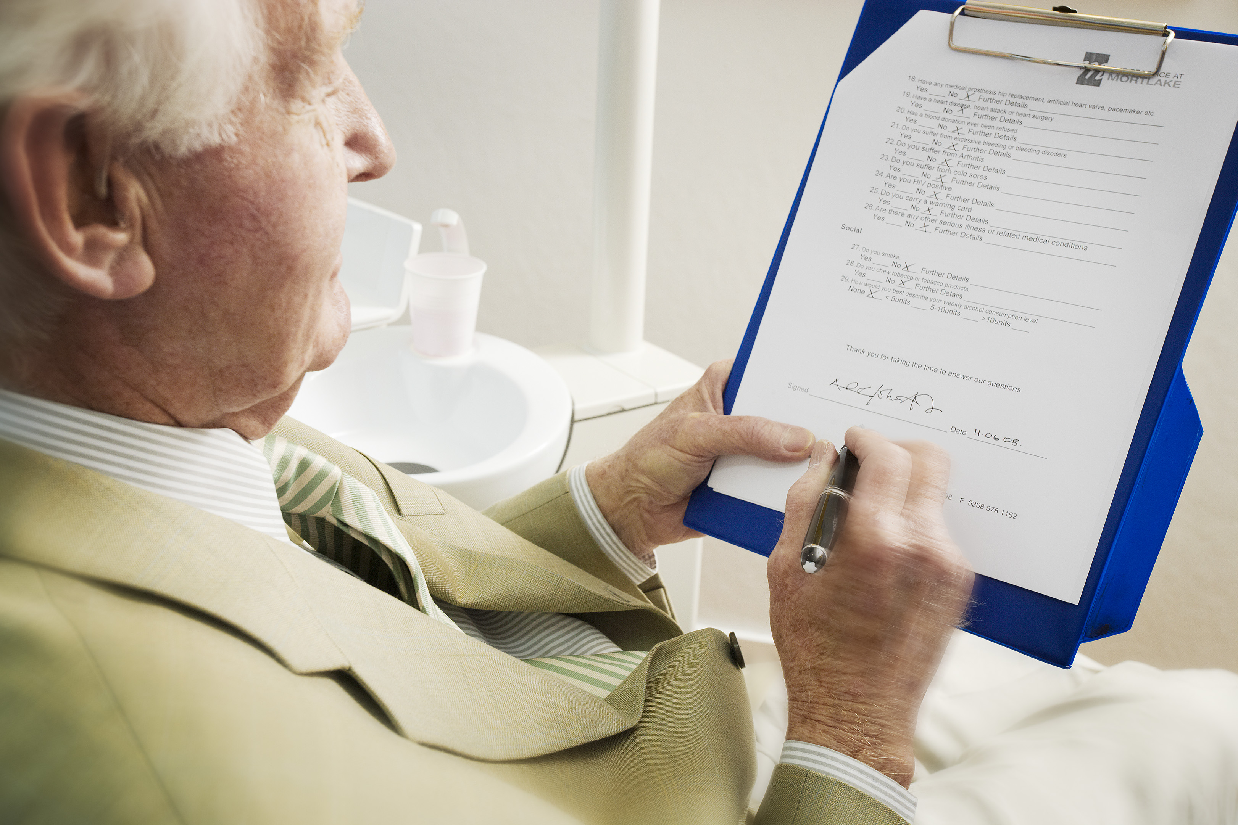

**Our guiding principle is that we hold your records in**

**strict confidence.**

**Freedom of Information (FOI) Act 2000**

The Freedom of Information Act, gives the general right of access to all types of recorded information held by the practice. The intention of the Act is to encourage a spirit of openness and transparency in the NHS and the whole public sector. Our organisation aims to fully support this.

Any individual or organisation can make a request for information. The applicant does not have to explain why this information is requested.

**Our Publication Scheme**

This practice has developed a publication scheme. It is a guide to information, routinely published and gives indication of information intended to be published. The publication scheme describes the form in which the information is published and any fees that will be charged. A request can be made from information listed in this publication scheme.

If you would like a copy of our publication scheme please contact the Data Controller.

